NUCLEAR DETECTION SENSOR

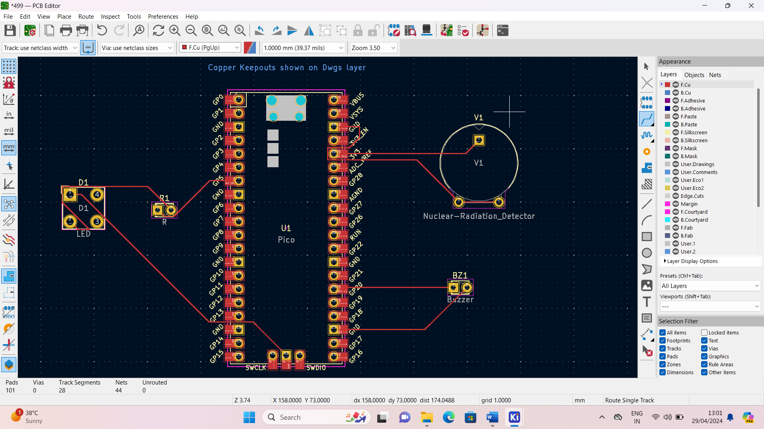

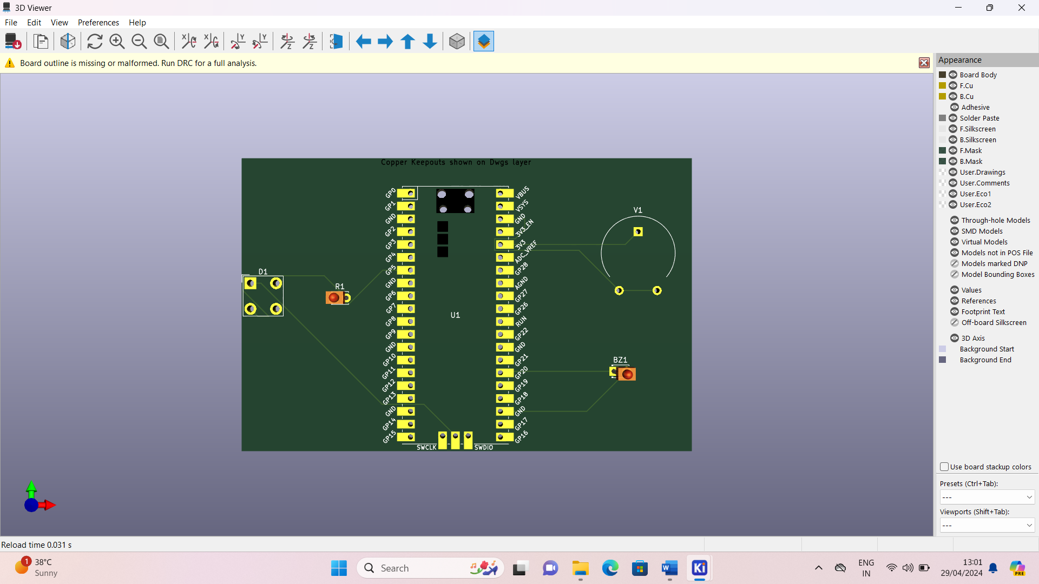

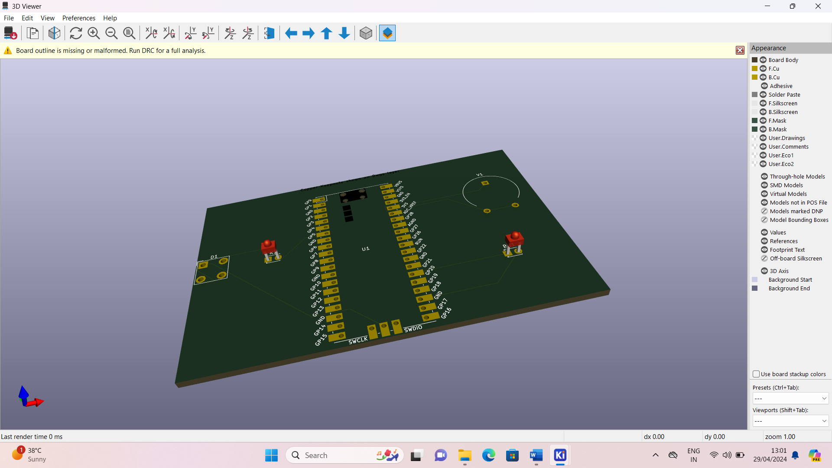

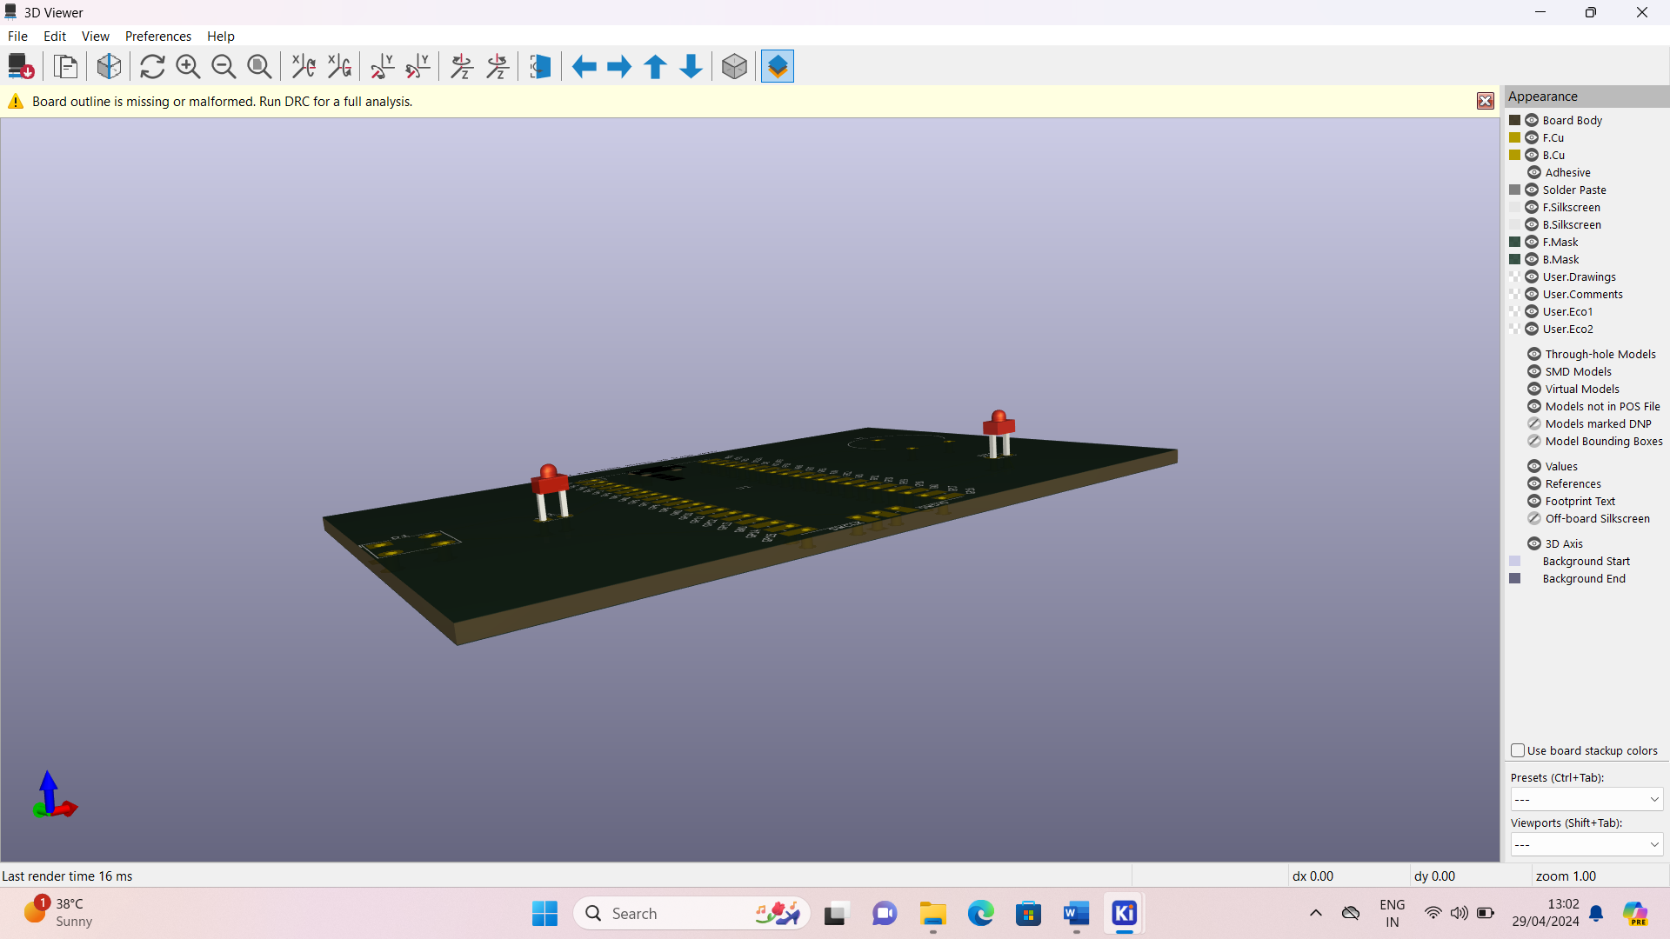

PROJECT BY :

1. K.Pallavi (21781A0499)
2. K.Kumudeswari (21781A0497)